D.2.x.x. Deliverable Title

Title | D.2.x.x. Deliverable Title
Creator | EGIDA
Creation date | 15/09/2011
Date of last revision | 30/10/2011
Subject | GEO label
Status | Draft Final
Publisher | EGIDA WP3
Type | Text
Description
Contributor | BLB, Bente Lilja Bye, Norway  Hans-Peter Plag, IEEE, Nevada Bureau of Mines and Geology,  University of Nevada, Reno, USA  Ian McCallum, IIASA, Austria  Joan Masó, CREAF, Spain
Format | Doc
Source
Rights | Restricted Public
Identifier | 0000.doc
Language | En
Relation | WP3
Coverage | Not applicable
These are Dublin Core metadata elements. See for more details and examples http://www.dublincore.org/

Version history (to be removed before publication)

Version number | Date | Modified by  (name and e-mail) | Comments
TABLE OF CONTENTS
D.3.2. Proposal for a GEO label 1
1. Introduction 6
2. Background 8
3. Current view of the GEO label 10
4. Connection to other initiatives 15
5. Summary & Way Forward 16
6. APPENDICIES 17
Appendix I 18
Appendix II 20
Appendix III 23
Appendix IV 30

FIGURES

No table of figures entries found.

TABLES

No table of figures entries found.

Introduction

As described in the EGIDA Project (http://www.egida-project.eu/) Description of Work, the goal of this activity (WP3.2) is the development of a “GEO label” concept related to the scientific relevance, quality, acceptance and societal needs for services and data sets of GEOSS. The GEO label on services, observations, and other data sets would not signal “ownership” of the entity by GEO but rather ascertain a user of the fact that GEO, among others, has assessed scientific relevance, quality, and correspondence with societal needs. This is important to support multi-disciplinary and advanced chaining and processing services. Such a label would be developed as an attractive incentive for involvement of the S&T communities in GEOSS and for their contributions to GEOSS. The STC has provided a draft document outlining the principal concept of the GEO label (Appendix I), and ST-09-02 is in the process of further developing these initial thoughts. EGIDA will support the ST-09-02 activities and:

- Further develop the draft concept for a GEO label and ensure that this concept is
acceptable for major Earth Observation data providers.
- Present the fully developed draft concept to the STC and, if necessary, adapt it according
to guidance from the STC.
- Support the STC in getting GEO-wide acceptance of the GEO label.
- Support the STC in implementation of the Label by applying the concept to a number of
carefully selected services, observations, information, and data sets.

The concept of the GEO label is currently being pursued by two EU Projects, namely EGIDA and GeoViQua (http://www.geoviqua.org/). In addition, the QA4EO Project (http://qa4eo.org/) is working on related quality issues, in addition to other GEO tasks which deal with data quality issues.

Within GeoViQua, a spatial quality indicator (a GEO label) will be defined to ensure at maximum users knowledge about quality when using spatial data, an issue particularly critical in scientific studies. GEO label requirements will be firstly mined and determined, integrated into all GeoViQua components, validated and applied by the pilot cases, and finally disseminated to the community. This theoretical and methodological definition will be complemented in collaboration with the FP7 EGIDA project and the task team of ST-09-02, responsible for developing and promoting a GEO label in GEOSS.

CEOS (the space arm of GEO), through discussion with calibration and validation experts from around the world, established QA4EO to facilitate interoperability of GEO systems. QA4EO is based on the adoption of guiding principles, which are implemented through a set of key operational guidelines derived from best practices, for implementation by the GEO community. Although these guidelines were originally developed to meet the needs of the space community, they have been written with the aid of national metrology institutes of the UK and the USA and, where appropriate, are based on best practices of the wider non-EO community.

The purpose of this document is to assemble in one report, the various efforts to date related to the GEO label concept, synthesize these and suggest possible future steps. As much of the effort thus far concerning the GEO label has occurred in the form of meetings, discussions, presentations, etc., with little in the way of documentation, the creation of a document is timely.

Background

The idea of the GEO label was initiated during the discussion of the S&T Road Map developed by the STC, and later refined during a meeting in February 2009, in which the two S&T Tasks were defined. During these discussions different ideas about the label were voiced ranging from a simple logo to be placed on data obtained via GEOSS, to a label assigned after thorough assessment and conveying information on quality and relevance. The concept of a GEO label appeared already in the STC Roadmap in 2009. In the Task Sheet of ST-09-02, the related activity is defined as “Establishing a “GEO label”. Develop a concept for a “GEO label” related to the scientific relevance, quality, acceptance and societal needs for activities in support of GEOSS as an attractive incentive for involvement of the S&T communities. A draft concept will be proposed in early 2010 liaising with existing major Earth observation data providers.”

The STC Roadmap provides the following description regarding the GEO label:
Activity 2b: Establishing a “GEO label”
Activities supporting an assessment of the scientific relevance, quality, acceptance and societal needs for activities in support of GEOSS can be developed further to establish the GEO-indicators as citable reference in other contexts, e.g. supporting funding proposals.

Propose a draft “GEO label” concept | ST-09-02 | Q2/2011
Discuss potential of developing the “GEO label” as an attractive incentive for involvement of the S&T communities and initiate the relevant activities | STC | 2011
(Annex to S&T Roadmap, version 2, 11.12.2010)

During several ST-09-02 meetings in 2009 and 2010, options for the GEO label were discussed, and it became clear that there is a wide range of opinions about what a GEO label should be and should not be. No agreement could be reached concerning the level of assessment that should be the basis for the GEO label. Therefore, in March 2010, ST-09-02 asked the STC co-chairs for more guidance in response to this request.

The STC produced an initial document on the GEO label for discussion (Appendix I). The document proposes a label based on objective and subjective criteria, and requests that the GEO label should be voluntary in its application. Moreover, the level of assessment carried out by GEO should be minimal or zero and the label should be based on self-assessment. This guidance has caused difficulty in further discussions, as the usefulness of a label based on self-assessment has been questioned both by ST-09-02 Task Team members and by the EGIDA and GeoViqua project teams. As mentioned above, the placement of the GEO label on a data set, product or service should ascertain a user of the fact that GEO, among others, has assessed scientific relevance, quality, and correspondence with societal needs. Furthermore, self assigned labels might lead to a degradation of the trustworthiness of GEOSS. Self-assigned labels also adds further burden to those who wish to provide data (i.e. they must additionally rate their data). A voluntary label also has disadvantages, e.g., it could potentially lead to only some portion of the data being labeled, and hence comparison between labeled and un-labeled data would be difficult. However, the concept of a label based on different classes of criteria (objective and subjective) is of relevance and in general accepted (e.g. the use of user ratings has general acceptance).

The most open discussion to date on the label occurred at the STC (Appendix I) and ST-09-02 meetings in September, 2010 (Appendix II). Particularly in the discussion at the ST-09-02 meeting, a wide array of opinions were voiced with a general lack of consensus on the issue. A clear outcome from this meeting was that a non-voluntary approach implemented from within GEO would not be accepted.

A review of labeling in general was undertaken within EGIDA in an attempt to provide relevant showcases of labels that could apply to GEO (Appendix III). Resulting in part from this, an application was made for a new project which would develop an independent data certification body (Appendix IV).

As a reaction to the discussion at the 2010 ST-09-02 meeting, Beyond Sustainability AS, Norway, has developed an alternative avenue for the labeling and certification of geo-reference entities to be implemented outside of GEO. Under the lead of Beyond Sustainability, a proposal has been submitted to EuroStars (Appendix IV). The proposed commercial approach to a Geo label would result in a label based on quality criteria, user acceptance, and the match to societal needs. Certification of products and services would be an additional option.

Current view of the GEO label

New benefits and goals for the GEO label have emerged from the discussions to date and they are enumerated here:

The GEO label could be an attractive incentive for involvement of the S&T communities. Getting a GEO label will give recognition for contributions; enable credits for providers (attribution) and support forward traceability (usage).


(illustration on how an hypothetic GEO label could respond to this goal)

The GEO label will stimulate the promotion of data sharing and could signal data availability and expose access and usage conditions.

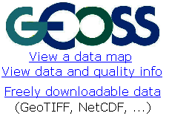
(illustration on how an hypothetic GEO label could respond to this goal)

The GEO label could provide a way to easily transfer information to users. It will increase trustworthiness, characterize quality, characterize applicability, and ensure backward traceability (data sources). This will also help in communicating metadata information in an easy way and convey visual information that will make it easy to compare resources.
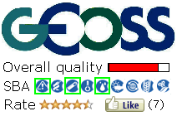
(illustration on how an hypothetic GEO label could respond to this goal)

An active GEO label attached to products could electronically collect inform about data usage and will help to extract information on relevance. This information is vital for data providers to know the user needs and how to fund and plan new products.

The GEO label is also the first step in the direction of a data certification.

(illustration on how an hypothetic GEO label could respond to this goal)

Further, to illustrate these goals, we present some user stories in the form of three UML models. The first UML graphical representation involves the easy transfer of information to a user and collects information about data usage and relevance. You can see how a contributor to GEOSS can include a dataset in the GCI and provide well documented quality information that could be either a measure or a document that contains traceability information (that eventually could be certified by some certification body). After this process the dataset receives a GEO Label. On the other hand, an EO user that searchs for an EO product can explore the GEO Label information and easily compare it to other datasets and eventually decide on which product to use. After using the product the EO user can return to the portal and provide feedback that can be used to modify some indicator included in the GEO Label.

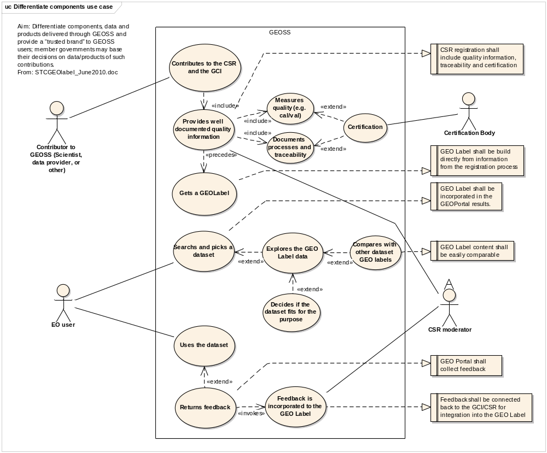
UML use case model that involves the easy transfer of information
to users and collects information about data usage and relevance goal.

The second UML graphical representation involves an attractive incentive for involvement and GEOSS promotion. A contributor to GEOSS approaches the GCI to submit a dataset. After getting reviewed and approved, the contributor gets a GEO Label that will be included in the contributors website and documentation. Then an EO user visits the contributor website or gets some documentation and sees the GEO Label. The EO user gets curious and visits the GEO portal discovering GEOSS potentialities in general.
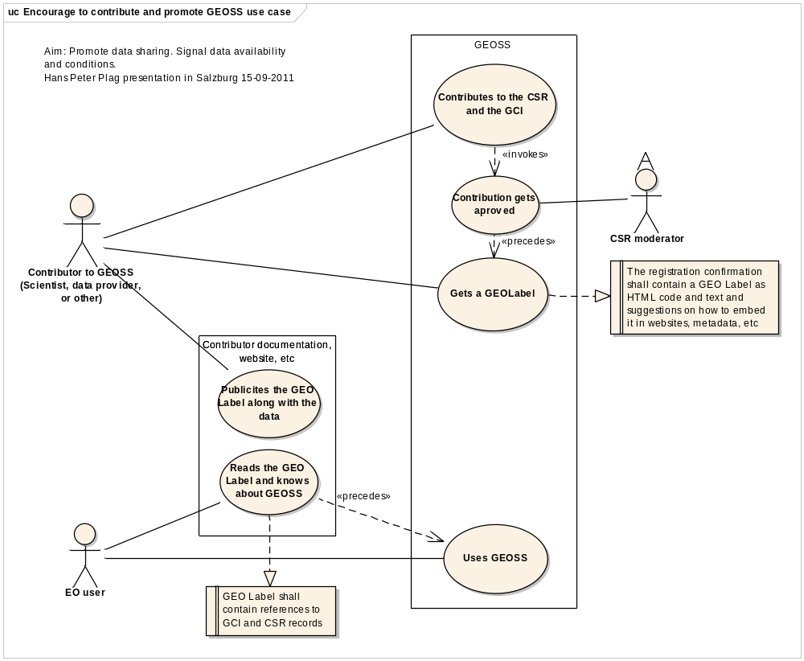
UML use case model that involves an attractive incentive
for involvement and GEOSS promotion.

The last UML graphical representation involves promoting data sharing and free availability of data. When a contributor registers a dataset to the GCI he needs to provide information on the availability and conditions of use and, only by providing that, the contributor gets the GEO Label. If the access conditions are compatible with the GEOSS data core requirements, the GEO Label reflects that.

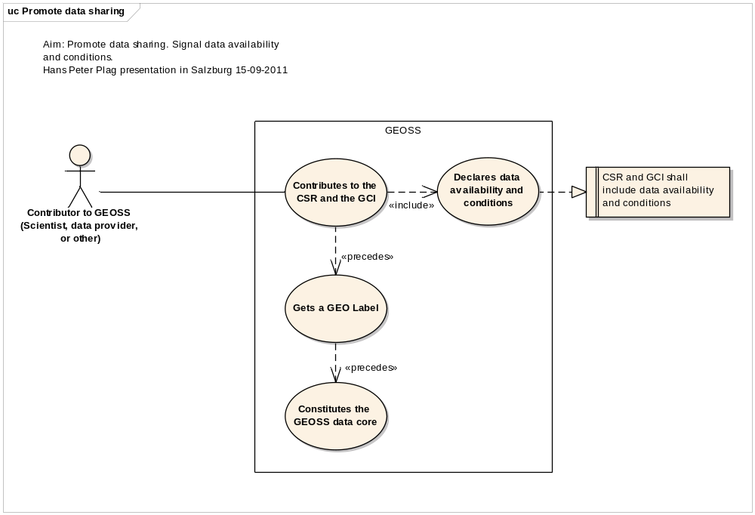
UML use case model that involves promoting data sharing
and free availability of data.

Connection to other initiatives
The GEO Label idea is connected with other initiatives and complements them. The GeoViQua FP7 project will work to include a quality model and encoding strategy (in connection with QA4EO) to set up the foundations for a new GCI quality recording that will make it possible to include quality indicators in the GEO label. One of the projects objectives is to participate in the definition of the GEO Label and also testing the chosen approach with real GCI data and to validate the idea by contributing tools to generate it.

The data citation standard is another activity promoted by the Science and Technology committee. The Data citation standard can be a powerful tool for getting an acceptance indicator of a particular dataset. The GEO label could be used either as a way to track usage of data or as a way to provide the exact citation statement for each dataset.

Quality of a dataset is a relative concept that depends on the purpose. Even datasets with poor quality indications can be very useful for an application that has low requirements on quality. The User Requirements Registry (URR) is another component of the GCI that is under development. It is a powerful tool for getting information about user needs and requirements. Including quality requirements in the URR will enable us to know the quality requirements for a particular application. This information can be used to extract information about the relevance of a particular dataset. This information can be included in the GEO label.

Summary & Way Forward

A meeting was held September 15th, 2011 between members of ST-09-02, EGIDA, GeoViQua and interested parties to discuss the GEO label. This meeting resulted in a general consensus on the next steps regarding the label:

- The goals of the GEO label have changed since inception and should be revisited.
- A user survey regarding the GEO label is urgently required (this is being led by GeoViQua).
- Voluntary labeling will likely not bring about desired results.
- An external certification body is needed that can independently apply such valuation on data (internal or GEO valuation will not be accepted by data providers).
- A user rating system should be implemented
- A document is required summarizing all GEO label related efforts to date (this document)

A user survey regarding the GEO label is currently being prepared by GeoViQua and will be ready in digital form on the internet in November, 2011. The Istanbul GEO plenary (November, 2011) will mark the kick-off of the survey that will last for 3 weeks. GeoViQua members will be at the EC booth in Istanbul at the GEO Exhibition to disseminate the GEO Label questionnaire and interview people there to collect the first results. Results of the data analysis will made available in the first quarter of next year.

In summary, the liaison between the three Projects EGIDA, GeoViQua and QA4EO is established and functioning. A lack of clear focus on the objectives of a GEO label has hampered progress to date. It is believed that a survey directed at data users and providers on the objectives and utility of a GEO label will help sharpen focus on the topic and provide direction.

Liason has also been established between the Geo label Eurostars proposal team and GeoViQua, EGIDA and GEO. EGIDA and GeoViQua partners are members of the Geo label proposal team, and the GEO Secretariat has agreed to be on the Advisory Board of the project, if it is funded. This will ensure that the commercial implementation of a Geo label will be consistent with the needs of GEO and the STC.

APPENDICIES

Appendix I

Source: STC, 2010
Developing a GEO label

The Science and Technology Committee roadmap committed the STC to developing the concept of a voluntary GEO label. This was intended to:
- encourage scientists, researchers, and others to contribute their data and systems to GEOSS by offering an accepted voluntary label that provides recognition that their contribution is valued by the GEO community.
- differentiate components, data and products delivered through GEOSS and provide a “trusted brand” to GEOSS users; member governments may base their decisions on data/products of such contributions.
- highlight the importance of GEOSS to those previously unaware they were reliant on this initiative for their data or product.
The STC roadmap states that such a label should assist the user to assess the scientific relevance, quality, acceptance and societal needs of the components. These parameters clearly contain a mix of objective and subjective assessments.

Conceptually, a GEO label could be broken into two categories:
1) Objective labelling (quality, reliability), and
2) Subjective labelling (relevance, usability)
Both ratings would be voluntary in application, and are meant to show value to both the user and provider.
- Objective Labelling (GEO Quality Label):-
GEO should develop a range of measures which support an assessment of the quality of the data or information provided by a system. These should generally be open to being validated by an outside observer. Criteria could include: registered in GCI, metadata completed, time frame of commitment indicated, point of contact listed, quality standard (e.g., peer review in open literature/ISO9001 accredited system; internal review/documented methodology available; not reviewed, provided as is) The GEO community will need to discuss and decide if any of these are defined as threshold criteria (ie. must be met to be eligible to carry a GEO Quality Label eg. Registered in GCI).

- Subjective Labelling (GEO community label):-
Subjective labelling relates to the relevance, acceptance and social utility of the GEOSS component, data, tool and is necessarily a subjective assessment by the user as to these parameters. STC has already discussed with ADC and UIC the concept of a user rating system as part of the GCI, and this is an appropriate mechanism for gathering such data on the subjective valuation of GEOSS components. The labelling of such subjective tools should be recognisably different from the labelling of the Objective quality tool and the Branding tool (e.g. this label could use a 5 star rating system similar to Amazon.com)

Thus, one could imagine a product, delivered using, or enabled by GEOSS bearing 2 possible labels e.g.:
The Big Important International Dataset on Water Borne Disease
Publisher: UNDP & WHO
GEO Quality Label: (Gold Medal rating) (print (maybe) and electronic)
GEO Community Label: (2.5 stars) (probably electronic only through GCI)
Alternatively, these two dimensions of the label could be combined into a single label, possibly categorized into different ranks.

Recommendation:
1) That STC through ST-09-02 develop the Objective Label concept further, in cooperation with relevant GEO tasks such as QA4EO, to arrive at a quality-related label for GEOSS components, datasets and tools. A robust proposal should be completed by Q2/2011.
2) That UIC plan for the development of Subjective labelling (GEO Community label), which may be implemented as part of future upgrades to the GCI. The conceptual development for the subjective labelling should be completed by Q2/2011.
3) That ADC oversee the implementation of the GEO label concept into future developments of the GCI.

Appendix II

Source: ST-09-02 Meeting Minutes, September 30, 2010, Rome, Italy
6 (15:15 - 16:00) The GEO label Report (STC Roadmap Activity 2b)
A preliminary incomplete draft label concept had been distributed to the members. The STC had discussed some aspects, and Hans-Peter Plag summarized some of the comments.
The GEO label was then discussed in detail. Gisbert Glaser opened the discussion by stating that there were different issues that needed consideration. He expressed the concern that it might be to early or at all no a good idea to attach a GEO label to data sets or products in the GEOSS registries. There was a need for more data sets to be registered, and he asked whether it could be an impediment to immediately rate the data sets. He also posed questions with respect to the methodology and specifically asked about the difference between the rating for 'Relevance' and 'User Needs'.
Hans-Peter Plag explained that 'Relevance' would be based on the subjective rating provided by individual users (comparable to restaurant or hotel reviews written by individual non-expert customers), while the 'User Needs' rating would be the result of an objective comparison of the data set to the requirements published in the URR (thus more comparable to the rating of restaurants agains well-defined criteria carried out, e.g., by Michelan). He stated that the choice of 'Relevance' for the former rating may not be a good one and proposed to use 'Perception" instead.
Marc Parsons saw conflicting thoughts in the label concept and requested that first it needs to be defined and nailed down what GEO wants to achieve with the label. He also saw a disconnect in the description of the label and the associated goals in the Task sheet.
Stuart Minchin voiced his opinion that the proposed label was overengineering the idea. He requested that the goal should be to have a label that is a stamp of quality and of usage. Scientist would then be able to take this back and say, I have a stamp from GEO. He also made clear that a label would only be supported as a voluntary option. He requested that providers can opt in or out, and stated that it should be up to the provider to decide which parts or which labels they want to be applied to their products.
Hans-Peter Plag explained that the concept described in the draft document does not exclude a voluntary label.
Stuart Minchin responded that in his opinion, the quality label should be based on self-assessment of the quality of products by the provider and explained that an independent assessment would not be accepted in the GEO community. Thus, providers should be able to decide whether theit datasets if silver, gold or platinum.
Marc Parsons agreed with Stuart Minchin and added that most data sets and products made available through GEOSS would not come from individual investigators but rather well established data centers and large organizations. He also requested that it would have to be clear that not having a star in the user rating would not imply that the data are not good. He proposed that user feedback should be implemented as a pilot project.
Hans-Peter Plag made clear that in his opinion the GEO label only makes sense if it can build trust for users, which would require independent assessment. Self-assessment would not be sufficient for trust building. He reported that Gilles Ollier identified a peer-reviewed publication analysing Arctic sea ice data, which cited as data source Google Earth. This motivated the call for a proposal focusing on the development of a label based on clear quality criteria in the last FP7 call. The goal was to create a chracterization of data sets that would make sure that researchers know what data sets to trust.
Marc Parsons expressed strong opposition against this idea and stated that scientific rigor requires that a researcher takes full responsibility to ensure that data is trustworthy before using it for studies. Stuart Minchin repeated his statements that a label based on independent assessment woul not be acceptable in the GEO community, and that the voluntary quality label should be based on independent assessment.
Bente Lilja Bye emphasized the need of a label that could be trusted. Refering to recent examples in the media, where scientists had been criticized for their data usage (e.g., Climate Gate, and the discussion of the global temperature data), she expressed the opinion that if scientists want to be trusted, an indendent judgement would help.
Joan MasÃ³ requested that the label would make a distinction between data not rated and data which were badly rated. He also had problem with the distinction between relevance and user needs. Hans-Peter Plag repeated some of his explanations mentioned above.
Jean-Louis Fellous reported on an attempt to create a confidence indicator. However, after trying different approaches, in the end the attmept was given up.
David Halpern proposed to use a scientific method in defining the label. He wanted to let people know what datasets are available, and then measure what data sets were being used. He rejected the idea of doing any evaluatation of data sets and recommended only to let users know know what is being used how much.
Stuart Marsh commented that this might work is if data sets were being cited, and Stuart Minchin added that he considered this only useful for some data sets.
Hans-Peter Plag once more emphasized that in his opinion an independed assessment of the products or data set to be labeled is needed. He emphasized the need for a trust-building label, which would help scientists in several aspects. Commenting on the previous proposal, he found that counting citation could be included in a label, but alone it could be mis-leading since data sets with important mistakes would have a tendency to be accessed and cited frequenty. He then informed the particpants that due to the time he would have to close the discussion.
David Halpern requested that Hans-Peter Plag would summarize and distribute the main points of the discussion, and Hans-Peter Plag responded that the discussion would be reflected as complete as possible in the minutes.
Finally, Hans-Peter Plag concluded that the discussion was not close to a reaching a consensus. In fact, the polarized positions raised the question whether GEO would be able to implement a trust-building label, and expressed his opinion that a label not designed to assure users of the quality and relevance of a data sets would not make very much sense. In this case, it would be better to have a data certification implemented by another organization outside of GEO. With respect to the proposed time schedule, he concluded that there was it was very unlikely that a label concept could be proposed to the next STC meeting, which also excluded the option to have a proposal ready for the discussion in the 2011 Plenary.

Appendix III

GEO label Literature Review

Source: BLB

Label
In general a label serves as a test or measurement indicator informing the user about the good in question (data, added-value data or data services) quality, fit-for-usages and user acceptance.

In GEO a label (Geolabel) will have to meet a set of field specific requirements. There are several ways of assessing, assuring and evaluating the quality, fit-for-usage and user acceptance of Earth observations.

Labeling requires a set of characterizations the good will be measured or tested against. In the case of Earth observations, there exist some globally accepted standards, like ISO standards, and other standards like ECV. These are requirements that also can be certified. There is also the possibility to test measure for compliance with certain characterizations.

To a large extent new global standards have to be developed within the field of Earth observations.

Managing labels: http://www.innovatum.com/pages/products

Organizational structure
Labeling can be performed and organized in different ways ranging from self-assessment (see VW BluePlanet) via private to public third party assessment resulting in a label or certificate of some sort.

When the goal is to achieve trustworthiness self- assessment is not really an option, but it can be seen used internally within a company who label their different product – product lines, mainly as part of a marketing strategy (“packaging” of their products)

Private-label and public-label concept
A third-party assessment is generally speaking more likely to be unbiased and hence more trustworthy. In principle anybody can offer to test or measure your goods/service and thus serve as a third-party. The more authority that third-party can document, either in terms of qualifications (can be private) and/or whom they represent (government, a large group of organizations etc), the more trustworthy the end user will perceive it. There are both private and public solutions or organizations that successfully provide that.

Foundation
International- national

[Definition of a label
Definition of compliance
Definition of certification]

List of certification bodies
http://www.bulltek.com/Registrar_Assistance/registrarassistance.html

Examples

Global Ecolabelling Network GEN is representing ecolabelling organizations: http://www.globalecolabelling.net/
Other organizations: INGO Accountability Charter http://www.ingoaccountabilitycharter.org/

EU-Ecolabel
Description of the label:
The European Ecolabel is a voluntary scheme, established in 1992 to encourage businesses to market products and services that are kinder to the environment. Products and services awarded the Ecolabel carry the flower logo.

This is a label that consumers can genuinely trust. The criteria are agreed at European level, following wide consultation with experts, and the label itself is only awarded after verification that the product meets these high environmental and performance standards.

The voluntary nature of the scheme means that it does not create barriers to trade. On the contrary - many producers find that it gives them a competitive advantage.

http://ec.europa.eu/environment/ecolabel/index_en.htm

Legal framework:
The EU Ecolabel is part of a broader action plan on Sustainable Consumption and Production and Sustainable Industrial Policy adopted by the Commission on 16 July 2008.

How is it organized:
European Union Eco-Labelling Board, "EUEB", consists of the Competent Bodies and other interested parties, and are the ruling body of the EU-Ecolabel. Competent Bodies are independent and impartial organisations, responsible for implementing the EU Ecolabel scheme at national level.

Competent Bodies: http://ec.europa.eu/environment/ecolabel/contacts/competent_bodies_en.htm

In order to ensure impartiality, relevance and quality interested parties are formally included in the management and development of the EU-Ecolabel through it Consultation Forum:

Rules of procedure of the Consultation Forum
1. The rules of procedure of the Consultation Forum (the Forum) referred to in Article 15 of Regulation (EC) No 1980/2000 are established. The Forum shall operate in accordance with the said Regulation.
2. The Consultation Forum and its members shall be members of the European Union Eco-Labelling Board (EUEB) and shall participate in all activities of the EUEB, in particular:
- requesting the Commission to initiate the procedure for setting the ecological criteria as well as the related assessment and compliance verification requirements for product groups,
- setting and reviewing Eco-Label criteria as well as the related assessment and compliance verification requirements for product groups,
- being consulted by the Commission on the Community Eco-Label working plan,
- the promotion and use of the Community Eco-Label.
3. The following organisations, amongst others, representing the interested parties referred to in Article 15 of the said Regulation, shall be members of the Forum, and thereby of the EUEB:
- Coface (consumers, representing also BEUC, Eurocoop and AEC),
- EEB (environmental),
- ETUC (trade unions),
- UNICE (industry)
- UEAPME (SMEs, crafts),
- Eurocommerce (commerce).

Read more about the management of EU Eco-label here:
http://ec.europa.eu/environment/ecolabel/about_ecolabel/who_does_what_en.htm

EU Ecolabelling Board
The European Union Ecolabelling Board (EUEB) is made up of the Competent Bodies from each Member State and the interested parties that form the Consultation Forum.
The EUEB, in collaboration with the Commission, is responsible for developing, publishing and promoting criteria for product groups in order to minimise the environmental impacts of a wide range of products and services over their whole life-cycle.
European Commission
The European Commission manages the scheme at EU level to ensure correct implementation of the Ecolabel Regulation. The Ecolabel Helpdesk assists the Commission on a number of different matters, including marketing.
Competent Bodies
Competent Bodies are independent and impartial organisations, responsible for implementing the EU Ecolabel scheme at national level. They are members of the EUEB responsible for drafting Ecolabel criteria, assessing applications and awarding the Ecolabel to companies that apply. They play a central role in the operation of the EU Ecolabel scheme and should be the first point of contact for any questions. For details of Competent Bodies see link below.
Regulatory Committee
The Regulatory Committee consists of governmental experts from the Member States. After the criteria are finalised they are voted upon by the Regulatory Committee. The Commission cannot adopt criteria before voting takes place in the Ecolabel Regulatory Committee by qualified majority.
Management groups
There are three management groups that meet regularly. The Ecolabel Working Plan specifies in a more detail the work to be done by the management groups.
- Policy management group
The objective of this group is to continue to develop and adapt the long-term policy and strategy of the scheme, as well as integrate the Ecolabel in various policies being developed in relation to sustainable consumption (such as green public procurement, labelling, etc.). For further information please contact the UK competent body (supported by the Danish competent body).
- Cooperation and coordination management group
The objective of the group is to progressively coordinate product group development in the different labelling schemes in the EU. For further information, please contact the Dutch competent body.
- Marketing management group
Marketing management group meetings are organised three times a year. All interested EUEB stakeholders develop and implement joint marketing initiatives. For further information please contact the Italian competent body or the Ecolabel Helpdesk .
Interest groups
Balanced participation is promoted by all relevant interested parties concerned with a particular product group, such as industry and service providers, including SMEs, crafts and their business organisations, trade union, traders, retailers, importers, environmental protection groups and consumer organisations. The development of different product groups may involve a combination of different interest groups. These interest groups are known as a Consultation Forum.

Pricing:
There is an application fee and a subscription fee. In addition there is an hourly rate for certification, validation, etc. Each nation choose their own pricing level with an upper and lower limit set by the EU for some of the costs.

http://ec.europa.eu/environment/ecolabel/ecolabelled_products/application_procedure_en.htm#before

European Ecolabels
A number of different labels co-exist with EU-Ecolabel. In Germany there is Blue Angel.

http://ec.europa.eu/environment/ecolabel/useful_links/other_ecolabels_en.htm

Nordic Swan
The Nordic Ecolabel is the official Nordic environmental ecolabel that symbolizes the work being done towards the goal of a sustainable consumerism. Our vision is a sustainable society. The idea behind the Nordic Ecolabel is to give consumers a tool to choose the best environmental products in the marketplace. For companies, it is a marketing tool to give extra value and credibility to a product. Since we are a third-party controlled, Type 1 Ecolabel, we have high credibility among consumers. The strength of our Nordic Ecolabel can help companies in their own marketing efforts.

Each of the Nordic countries have their own Swan label that are part of the Nordic Swan.

How is it organized:
The Nordic Ecolabelling Board consists of members from each national Ecolabelling Board and decides on Nordic criteria requirements for products and services. Criteria are applicable in all Nordic countries, and no country can develop its own criteria or product groups. When a product is granted a Nordic Ecolabel in one Nordic country, the company can even apply, through a simple application procedure, for a Nordic Ecolabel in the other Nordic countries.

Each Nordic country has local offices with the responsibility for criteria development, control visits, licensing and marketing. In Denmark Nordic Ecolabel is administered by Ecolabelling Denmark at Danish Standards Foundation, in Sweden by Ecolabelling Sweden AB, in Finland by Finnish Standards, in Norway by The Foundation for Ecolabelling, and in Iceland by the The Environment Agency that operates under the direction of the Ministry for the Environment.

Sweden: http://www.svanen.se/en/

EnergyStar
Description of the label:
ENERGY STAR as a voluntary labeling program designed to identify and promote energy-efficient products to reduce greenhouse gas emissions. Computers and monitors were the first labeled products.
The ENERGY STAR label is now on major appliances, office equipment, lighting, home electronics, and more. EPA has also extended the label to cover new homes and commercial and industrial buildings.

ENERGY STAR is a joint program of the U.S. Environmental Protection Agency and the U.S. Department of Energy with the goal of saving money and protect the environment through energy efficient products and practices.

How is it organized:
To ensure that ENERGY STAR remains a trusted symbol for environmental protection and superior energy efficiency, all ENERGY STAR product partners will be required to follow a new set of Third-Party Certification procedures starting January 1, 2011. To ensure a smooth transition to these new procedures, EPA has provided the following resources:

Third party certification system.
http://www.energystar.gov/index.cfm?c=partners.enhanced_test_verification

LEED
Description of the label:
LEED is an internationally recognized green building certification system, providing third-party verification that a building or community was designed and built using strategies aimed at improving performance across all the metrics that matter most: energy savings, water efficiency, CO2 emissions reduction, improved indoor environmental quality, and stewardship of resources and sensitivity to their impacts.

How is it organized:

Here is an overview of the LEED committees and their roles.
http://www.usgbc.org/DisplayPage.aspx?CMSPageID=1750

Ecomark
Description of the label:

http://www.ecomark.jp/english/syoukai.html

International recognition of ecolabels – links to the same kind of labels in Asia: Taiwan, Korea, New Zealand, Thailand...

http://www.ecomark.jp/english/sougo.html

Fairtrade Labelling Organizations International (FLO)
Description of the organization:

http://www.fairtrade.net/

EPSI – Extended Performance Satisfaction Index
Description of the (label) customer evaluation service:

http://www.epsi-norway.org/en/About-Us/this-is-epsi.html

OGC – Open Geospatial Consortium
Description of the label:
OGC focuses its resources on developing and publicizing standards for adoption and use by the geospatial community. Our trademarks and service marks have become widely recognized symbols of leadership and excellence in the technology field. Proper use of these marks is essential to avoid legal complications, and OGC will audit the use of the OGC trademarks to determine compliance with these guidelines.

OGC® and OpenGIS® are registered trademarks of the Open Geospatial Consortium (OGC). OGC is the brand name associated with the standards and documents produced by the OGC. OGC standards are developed in a unique consensus process supported by the OGC's industry, government and academic members to enable geoprocessing technologies to interoperate, or "plug and play". You will also find the OGC trademark associated with products that implement our standards and that have obtained the Certified OGC Compliant brand. Make sure that your geoprocessing and location services procurement and technology development programs demand OGC standards!

Compliance testing:
Compliance testing and the "Certified OGC Compliant" brand provide important benefits for product vendors and integrators as well as their customers and their customers’ stakeholders.

http://www.opengeospatial.org/compliance

Who owns it: It is a Inc owned by members of the industrial consortium (includes also governmental organizations)

How is it organized:
The Open Geospatial Consortium (OGC) is an international industry consortium of 417 companies, government agencies and universities participating in a consensus process to develop publicly available interface standards.

The OGC Board of Directors represents leadership from many disciplines and regions of the world. OGC Directors are dedicated to achieving the OGC vision, providing their professional expertise to the advancement of Consortium objectives. OGC Directors serve as individuals representing the needs of their sectors - they do not represent their organizations of employment.
Note: Jacqeline McGlade is a member of the board as is the CEO of British Ordnance Ms Lawrence

The OGC Board's Spatial Law and Policy Committee addresses spatial law and policy issues which will influence development requirements of the Consortium's technology process.

The OGC Board has also created the OGC Global Advisory Council as a committee of the board to function as a non-executive, "blue-ribbon" panel positioned to advise OGC concerning its global outreach and organizational strategies. This team is comprised of leaders in infrastructure development, government and industry who will help shape and focus regional activities throughout the world.

How is it financed:
OGC will not charge a fee for compliance testing under the Testing Procedure.
OGC will charge a fee for trademark licensing for Candidate Products that successfully pass a compliance test under the Testing Procedure; this fee is termed the Trademark Licensing Fee. This fee must be paid by organizations that wish to claim compliance with OGC Implementation Specifications. This fee is not required to initiate and complete a test. The current fee structure is found in the table below and in Appendix G-Trademark Licensing Fees of the Compliance Testing Program document.
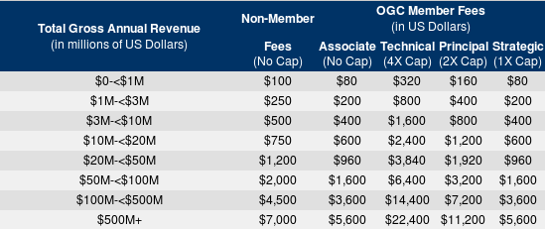

Appendix IV

Source: BLB and Beyond Sustainability AS, Norway
Eurostars Proposal

Complementary activity: Eurostars proposal: Framework for the labeling and certification of georeferenced data sets, products, and services:
- Core team of three companies (lead: Beyond Sustainability AS, Norway) will establish a service for labeling and certification;
- Use cases with participation of major stakeholders in several market segments (governmental agencies, space agencies, service providers, research institutes, private companies - infrastructure, re-insurance, ...)
- Global participation (Norway, U.K., Germany, France, USA, China, ...)
- Advisory Board with representatives of key international organizations to ensure wide acceptance



